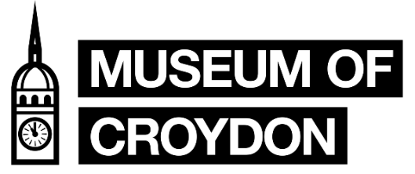
COLLECTIONS VOLUNTEER - General
Role Description
The Croydon Council collections are split into four main groups: the Borough Archives, Local Studies, Museum and Handling Collection. Additionally, to this we have an outreach public programme and two temporary exhibition spaces.
This collection volunteer role will be working directly with the Museum collection. The Museum collection consists of the Borough Art Collection of over 2,500 artworks, social history objects, over 500 oral histories, Bronze Age, Roman, Anglo-Saxon objects to over 200 items from the Riesco Collection of Chinese ceramics. From textiles, our Trojan Bubble car to an almost complete Anglo-Saxon skeleton – the collection is diverse in material and stories.
This volunteer role will be working directly back of house, with the Collections Officer. To monitor the exhibition galleries, help with audits of collection and to complete research for future public tours and exhibitions (Wednesdays only).
Tasks involved:
- Monitor and help maintain standards of display in the galleries. Alert Collections Officer to any issues with collection care of objects on display.
- Research stories and objects for future exhibitions and tours. Utilising resources found within the Archive and local history collection to improve our knowledge of the collection.
- Listing and cataloguing objects.
- Create and assist with hosting future tours of stored collections.
- Monthly checks of stored areas.
- Support Collections Officer in facilitating access to stored collections.
- Object handling (as needed)
- Provide research and/or content for social media and website collection pages (as needed)
- Working with staff and other volunteers.
- Be an advocate for the work of the Museum of Croydon.
- Help promote the Museum in the local area.
There will be opportunities with this role to be involved in exhibition install and/or other collection care projects. However, there is no guarantee those days will take place on Wednesdays.
Skills
- Excellent communication skills and attention to detail.
- Friendly and approachable attitude.
- Good organisation and ability to complete tasks independently and within a team.
- Experience of Microsoft Office, including Microsoft Excel.
- An interest in history and working with historical collections.

Time Commitment and Access
We ask you to commit to one day a week: Wednesdays 10am to 5pm for a minimum of three months. Please be aware that this role will require lifting of objects and access to museum storage areas that are only accessible via steps.
Unfortunately, this volunteer role is not suitable for under 18s due to task responsibilities and lone working. This role ideally suits, but is not restricted to, individuals that live locally.
Support and Training
- Full induction and relevant training.
- Ongoing support through Volunteer Co-ordinator and Collections Access Officer.
How to Apply
We invite anyone interested in this role to apply via Better Impact as a ‘Museum of Croydon – Collections Volunteer’, please follow link here to Better Impact. If you have any questions in regard to this role, please email museum@croydon.gov.uk

Please note: Applicants from some overseas countries are required to have a relevant work permit or student visa in order to volunteer in the U.K. By applying you are confirming you have the correct documentation that permits you to volunteer at the Museum of Croydon. Please note this may have to be shown prior to start.

